**BANNARI AMMAN INSTITUTE OF TECHNOLOGY**

**SATHYAMANGAM-638401**

(An Autonomous Institution Affiliated to Anna University, Chennai)

**IOT Based Safety Gadget for Child Safety Monitoring and Notiﬁcation**



|  |  |
| --- | --- |
| TITLE | IOT Based Safety Gadget For Child Safety Monitoring And Notiﬁcation |
| DOMAIN NAME | INTERNET OF THINGS |
| TEAM ID | PNT2022TMID018228 |
| TEAM LEADER NAME | SABARINATHAN G |
| TEAM MEMBER NAME | PATHMALOSHAN C  PRANEETH R  RITHIK M |

# CONTENT

#### INTRODUCTION

* 1. Project Overview
  2. Purpose

#### LITERATURE SURVEY

* 1. Existing problem
  2. References
  3. Problem Statement Deﬁnition

#### IDEATION &amp; PROPOSED SOLUTION

* 1. Empathy Map Canvas
  2. Ideation &amp; Brainstorming
  3. Proposed Solution
  4. Problem Solution ﬁt

#### REQUIREMENT ANALYSIS

* 1. Functional requirement
  2. Non-Functional requirements

#### PROJECT DESIGN

* 1. Data Flow Diagrams
  2. Solution &amp; Technical Architecture
  3. User Stories

#### PROJECT PLANNING &amp; SCHEDULING

* 1. Sprint Planning &amp; Estimation
  2. Sprint Delivery Schedule

#### CODING &amp; SOLUTIONING (Explain the features in the project along with code)

* 1. Feature code 1
  2. Feature code 2

#### TESTING

* 1. Test Cases
  2. User Acceptance Testing

#### RESULTS

* 1. Performance Metrics

#### ADVANTAGES &amp; DISADVANTAGES

1. **CONCLUSION**

#### FUTURE SCOPE

1. **APPENDIX**

Source Code

GitHub &amp; Project Demo Link

# INTRODUCTION:

## **Project Overview:**

Internet of Things (IoT) is a set of systems and devices interconnected with real-world sensors and actuators to the Internet. It is able to make decisions via detecting the surrounding environment without human interaction. In this project, IoT is applied to propose which helps parents to monitor and get known of their child’s condition at anywhere and anytime even if they are not by their children side, Via the IoT, children safety is guaranteed, and crime rate is reduced as immediate actions can be taken in case the child is in danger. The use of IoT in this device is motivated by the need of child security system. Enable tracking of the child’s location and capturing of data remotely such as temperature, Latitude and Longitude .To show the child's actual data with reference values. Enable sending of notiﬁcation if the child is out of location or when the device realizes abnormal conditions/situations. Then, emergency notiﬁcation will be sent to and display in the parents' mobile apps. Cloud computing means shared computing resources (networks, servers, storages, applications, services) are delivered as a service over the Internet from cloud to parent’s. According to cloud is an interconnected network of servers providing services for people. With the help of cloud we store the entire location data.

## **Purpose:**

It assists parents to monitor their children remotely. In case situations happen, notiﬁcations will be sent to parents so that actions can be taken. Through this child safety can be ensured and crime rate will be reduced. Parent’s concentrate to their works without worrying about their children.

# LITERATURE SURVEY:

## **Existing problem:**

Paper 1:

The tracking system is used to track moving individuals and provide an instant timeline of position information for tracking analysis. People Tracking System in the crowd for Smart Cities is a mobile application that allows parents to monitor the location of their children in a crowded environment. Besides children, there are also elderly and disabled people, so the person responsible for them can use this application to track their location. The parents have the application in which they can track the location and on the other hand, the child or the old person or the disabled person has a device that contains the Global Positioning System chip. The main objective of this study is to design an application with the system that will help the parents to track their children to reduce the cases where the children or the other mentioned categories of people might get lost. The current solution to this problem is that the children ﬁrst have a wearable wrist where they imprint the phone number of their parents so that if the child is lost, there is an ofﬁce where the child is taken and taken care of until they contact the parents to come and pick up the child. The problem with the current way that it takes time and there is a risk that child will be lost or kidnapped before ever reaching for any help, so the new way is better to also prevent them from going far away or being lost for hours, so the recovery here will be quick unlike the regularly used way today. This goal will be achieved by systematic objectives, starting from studying the existing systems, planning, and analyzing, designing, and implementing, and ﬁnally testing the proposed system.

### Paper 2:

Recently, all over the world, crime against children is increasing at higher rates and it is high time to offer safety support system for the children going to schools. This paper focuses on implementing children tracking system for every child attending school. However the existing systems are not powerful enough to prevent the crime against children since these systems give information about the children group and not about each child resulting in low assurance about their

child safety to parents and also does not concentrate on sensing the cry of the child and intimating the same to its parents. The proposed system includes a child module and two receiver modules for getting the information about the missed child on periodical basis. The child module includes ARM7 microcontroller (lpc 2378), Global positioning system (GPS), Global system for mobile communication (GSM), Voice playback circuit and the receiver module includes Android mobile device in parent’s hand and the other as monitoring database in control room of the school. Finally, implementation results for the proposed system are provided in this paper.

### Paper 3:

What the world is seeing about the deterioration of public safety in various cities and the increase in the rate of crimes against children makes parents constantly worry about their children when they go to school and until they return from it. To dispel these fears, the idea emerges to create an application that allows parents to know the whereabouts of their children and notify them with a message if the children exceed the area speciﬁed for them. In this application, the process of discovering the child's precise location in a speciﬁc area is carried out by determining the latitude and longitude using the GSM radio navigation system. After that, the mobile receives all the information about the location via the GSM modem. A GSM modem has been programmed to achieve communication between the modem and the child by two methods of communication through which the child's location is determined. Ensuring that the child's location is known at any time and informing the person responsible for tracking him is the primary function of this system. This device connects to the child in an appropriate manner and it turns on when the child exits the designated area for him, after which a message is sent to the tracker. The device can be triggered using a short messaging system (SMS) where the user can communicate remotely to the GSM using a mobile.

### Paper 4:

Recently, all over the world, crime against children is increasing at higher rates and it is high time to offer safety support system for the children going to schools. This paper focuses on implementing children tracking system for every child attending school. However the existing systems are not powerful enough to prevent the crime against children since these systems give information about the children group and not about each child resulting in low assurance about their

child safety to parents and also does not concentrate on sensing the cry of the child and intimating the same to its parents. The proposed system includes a child module and two receiver modules for getting the information about the missed child on periodical basis. The child module includes ARM7 microcontroller (lpc 2378), Global positioning system (GPS), Global system for mobile communication (GSM), Voice playback circuit and the receiver module includes Android mobile device in parent’s hand and the other as monitoring database in control room of the school. Finally, implementation results for the proposed system are provided in this paper.

### Paper 5:

Nowadays, crime rate associated with children keeps increasing due to which draws peoples’ attention regarding child safety. This research is conducted to propose a child security smart band utilizing IOT technology. Online questionnaire and semi-structured interview are methodologies used to collect data. The online questionnaire gains feedbacks by sending questions electronically, where answers need to be submitted online. In the semi structured interview, researcher meets and asks respondents some predetermined questions while other being asked are not planned in advanced. Through information obtained, a smartband have been proposed to monitor the safety of children. By this, parents know what is happening remotely and can take actions if something goes wrong. The future improvements of this device will be adding functions and software to make it works like a phone such as messaging, gallery, Google, YouTube, meanwhile, adding more child security features sothat child safety is guaranteed.

### Paper 6:

Now-a-days attacks on children are increasing at an unprecedented rate and the victims are in dangerous conditions, where they are not allowed to contact the family members. The key idea planned in this research work is an advanced technology that offers “Smart Child Safety” for the children. Therefore, the awareness of this method is to send an SMS from children’s wear tool to their parent or guardian. In the prevailing structure, there is no monitoring method for child, it should create many problems for them and the no protection mechanism to protect the child from the misbehavior. In addition, there is no aware device for the child’s protection; it must be completed by hand only. Thus, the planned method will be highly effective when compared to the other existing techniques in

helping the victims. Moreover, it doesn’t need any manual operation. This paper recommends a newfangled technology for child protection by using GSM so that the children will not feel abandoned while facing such social problems. The problems overawed here using Arduino UNO, GSM, sensors, MEMS, temperature and panic button by using IOT. In such case, Heartbeat Sensor tracks the best rate for children and sends the emergency message by using the GSM to save contacts. Such method is actually supportive for children in today’s world. Hence, this provides a security to the children and secures the feeling of parents.

### Paper 7:

Today, technology is growing rapidly and providing all essential and effective solutions for every requirement. Now a day’s child security is an important area of concern. This model is developed to rectify the worries of parents regarding their child security. In this scenario, our system ensures maximum security and ensures live tracking for their kids because parent worries are genuine. This paper proposed a model for child safety through smart phones that provides the option to track the location of their children as well as in case of emergency children is able to send a quick message and its current location via Short Message services. This proposed system is validated by testing on the Android platform.

Paper 8:

Safety of a child in a large public event is a major concern for event organizers and parents. This paper addresses this important concern and proposes an architecture model of the IOT- enable smart child safety tracking digital system. This IOT-enabled digital system architecture integrates the Cloud, Mobile and GPS technology to precisely locate the geographical location of a child on an event map. The proposed architecture model describes the people, information, process, and technology architecture elements, and their relationships for the complex IOT-enable smart child safety tracking digital system. The proposed architecture model can be used as a reference or guide to assist in the safe architecture driven development of the various child tracking digital systems for different public events.

### Paper 9:

The objective of this project is to safeguard the child from threads. Now a day the safety measures of children have been reduced in huge number. Thus the violence against children increasing day by day. Not only kids even women are also abused both physically and mentally. We are taking small step towards violence against the kids. Our project mainly focus on sensing the children’s Temperature and Heartbeat. By monitoring the activities the state of the child is analyzed. By using GSM, if child reaches the critical state then the latitude and longitude of that particular location is sent as an alert message to the parents. In this system, it has a MEMS sensor which is used to detect the abnormal vibration and it is controlled by NodeMCU micro controller.

Paper 10:

The objective of this project is to safeguard the child from threads. Now a day the safety measures of children have been reduced in huge number. Thus the violence against children increasing day by day. Not only kids even women are also abused both physically and mentally. We are taking small step towards violence against the kids. Our project mainly focus on sensing the children’s Temperature and Heartbeat. By monitoring the activities the state of the child is analyzed. By using GSM, if child reaches the critical state then the latitude and longitude of that particular location is sent as an alert message to the parents.

## References:

### Paper 1:

Designing and implementing the people tracking system in the crowded environment using mobile application for smart cities. The Society for Reliability Engineering, Quality and Operations Management (SREQOM), India and The Division of Operation and Maintenance, Lulea University of Technology, Sweden 2021

### Paper 2:

Proceedings of the 3rd International Conference on Integrated Intelligent Computing. Communication & Security (ICIIC 2021)IoT-based Child Security Monitoring System

### Paper 3:

Design and Implementation of a Smart System for School Children Tracking

### Paper 4:

Design and Implementation of Children Tracking System using ARM7 on Android Mobile Terminals(September-2014)

### Paper 5:

Proceedings of the 3rd International Conference on Integrated Intelligent Computing Communication & Security (ICIIC 2021) -IOT-based Child Security Monitoring System

### Paper 6:

Proceedings of the Third International Conference on Intelligent Communication Technologies and Virtual Mobile Networks (ICICV 2021).Design of Wearable Device for Child Safety

Paper 7:

2016 Second International Conference on Computational Intelligence & Communication Technology- Child Safety & Tracking Management System

Paper 8:

2020 IEEE 14th International Conference on Semantic Computing (ICSC) -IOT-enabled Smart Child Safety Digital System Architecture

Paper 9:

Child Safety Wearable Device.(March 2019)

### Paper 10:

International Conference on Electrical Engineering and Computer science 2018, An Integrated Child Safety using Geo-fencing Information on Mobile Devices

## **Problem Statement Deﬁnition:**

* + 1. Child tracker helps the parents in continuously monitoring the child's location.
    2. They can simply leave their children in school or parks and create a geofence around the particular location.
    3. By continuously checking the child's location notiﬁcations will be generated if the child crosses the geofence.
    4. Notiﬁcations will be sent according to the child's location to their parents or caretakers.
    5. The entire location data will be stored in the database.

# IDEATION AND PROPOSED SOLUTION:

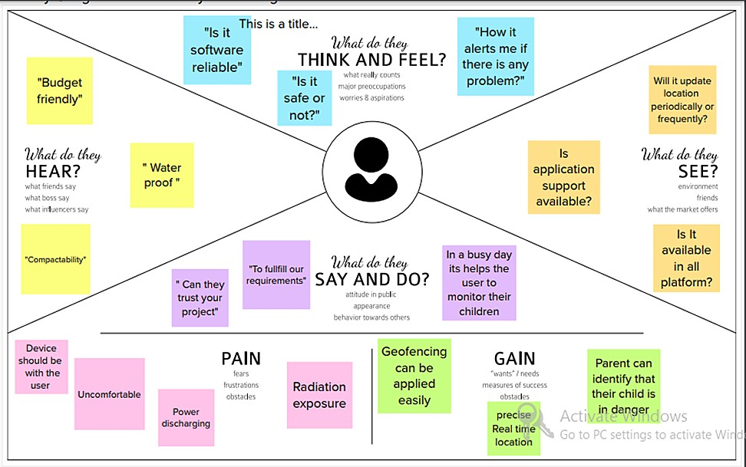

## **Empathy Map Canvas**

* 1. **Ideation and Brainstorming**

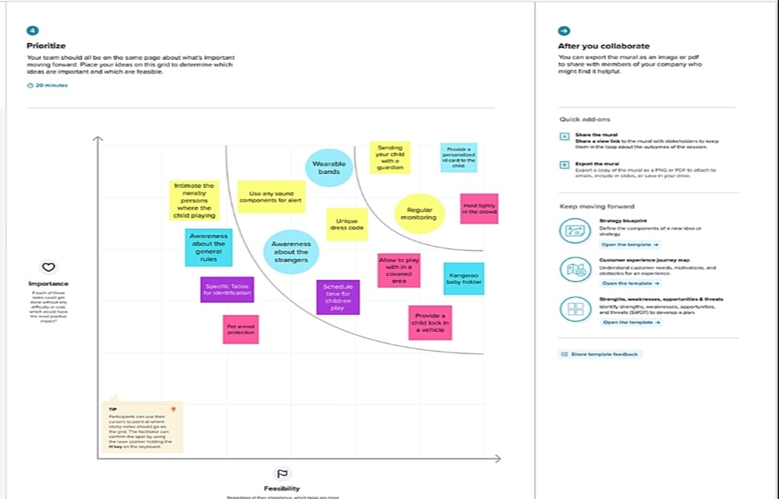

**Proposed Solution**

|  |  |  |
| --- | --- | --- |
| **S.No.** | **Parameter** | **Description** |
| 1. | Problem Statement(Problem to be solved) | 1. Child tracker helps the parents in continuously monitoring the child's location. 2. They can simply leave their children in school or parks and create a geofence around the particular location. 3. By continuously checking the child's location notiﬁcations will be generated if the child crosses the geofence. 4. Notiﬁcations will be sent according to the child's location to their parents or caretakers. The entire location data will be stored in the database |
| 2. | Idea/Solution description | 1. Without any Interruption of miscellaneous signal for better performance. 2. It should be compact and it is mostly a wearable one. |
| 3. | Novelty/ Uniqueness | 1. If the children cross the geofence area , Snapshot of the current location of the child is notify to the parents. 2. Without internet the device should be communicate within a short range. |

|  |  |  |
| --- | --- | --- |
| 4. | Social Impact/ Customer Satisfaction | 1. Parents do their work properly and peacefully. 2. Without disturbing the parents work ,only the device alert when the child crosses the geofence. |
| 5. | Business Model(Revenue Model) | 1. The cost of the device is satisfactory to both Customer and the manufacturer. |
| 6. | Scalability of the Solution | 1. To made a separate device for control the gadget. 2. It transmits the messages even in a hill regions. |

* 1. **Problem Solution Fit**

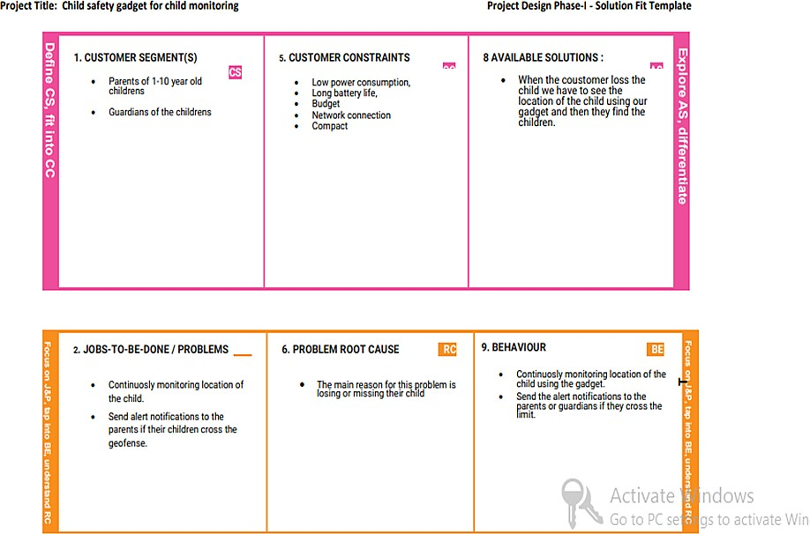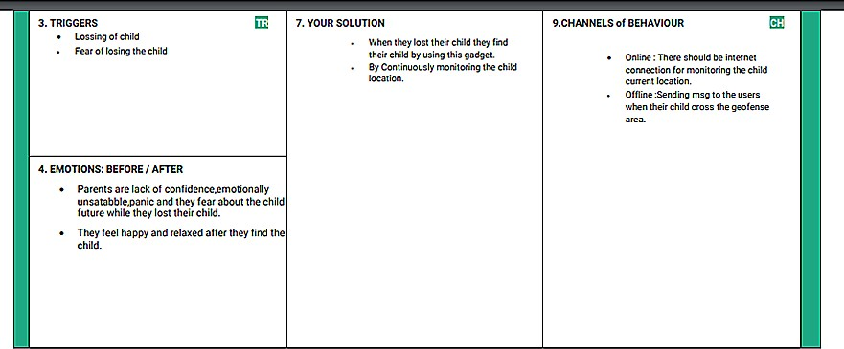

# REQUIREMENT ANALYSIS:

## **Functional Requirements:**

Following are the functional requirements of the proposed solution.

|  |  |  |
| --- | --- | --- |
| **FR No.** | **Functional Requirement (Epic)** | **Sub Requirement (Story / Sub-Task)** |
| FR-1 | Communicate and exchange information to provide server for user | 1. To monitor the children’s location continuously in schools or parks. 2. Alert the parent if the child crosses the geofence through SMS. |
| FR-2 | Continuous monitoring | 1. Create the geofence around child location. 2. Continuously monitoring the child location. 3. Notiﬁcations send when child cross   the geofence and chid face any issues. |
| FR-3 | User requirement | 1. Easily upgrade to any environments. 2. Easy to handle. 3. Gives more accuracy. 4. Low power consumption. |

|  |  |  |
| --- | --- | --- |
| FR-4 | Mandatory | 1. The system will send the detail of location information the system via 3G network or Wi-Fi. 2. Accuracy of location is important. 3. The system should be scalable. 4. The entire location data will be stored |
| FR-5 | Testing  Set the geofence. | 1. The device is kept together with the children. 2. Create geofence around the child location in school or parks, if child crosses the geofence notify to the parents 3. Notiﬁcations sent in the form of SMS. |

* 1. **Non-Functional Requirements :**

|  |  |  |
| --- | --- | --- |
| **FR No.** | **Non-Functional Requirement** | **Description** |
| NFR-1 | **Usability** | 1. High usability of user experience design for user, 2. Which is usable for ﬁnding the children if they lost. |
| NFR-2 | **Security** | 1. The system can accessed by authorized persons only. |
| NFR-3 | **Reliability** | 1. Monitoring the location continuously and easy to upgrade the system . |
| NFR-4 | **Performance** | 1. The performance should be more effective and eﬃcient. 2. The location data will be stored. |
| NFR-5 | **Availability** | If we are going to upgrade the system or make any changes in the the system it will not take much time to recovery. |
| NFR-6 | **Scalability** | 1. The website traﬃc limit must be scalable enough to 2. support users at a time. |

# PROJECT DESIGN

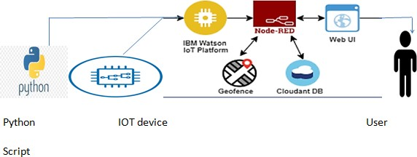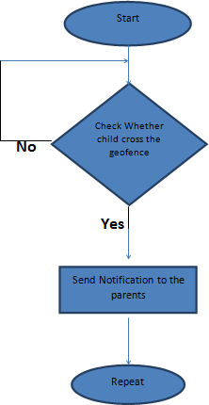

* 1. **Data Flow Diagrams:**
  2. **Technical Architecture:**

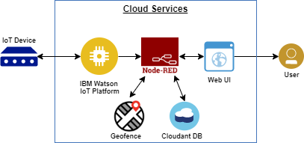

* + 1. Feed the data from the GPS placed in the Device to the web interface.
    2. The data will display in the web page of the authority(user)
    3. The collected data is sent to the data base, where the collected location and pre deﬁned geophone location are checked and monitored if the child cross the geophone notiﬁcation sends to the parents.
    4. The location data is provided to the cloud service and stored
    5. The authority monitors the web page continuously to collect the location data and send the alert to the authority

**Components and Technologies:**

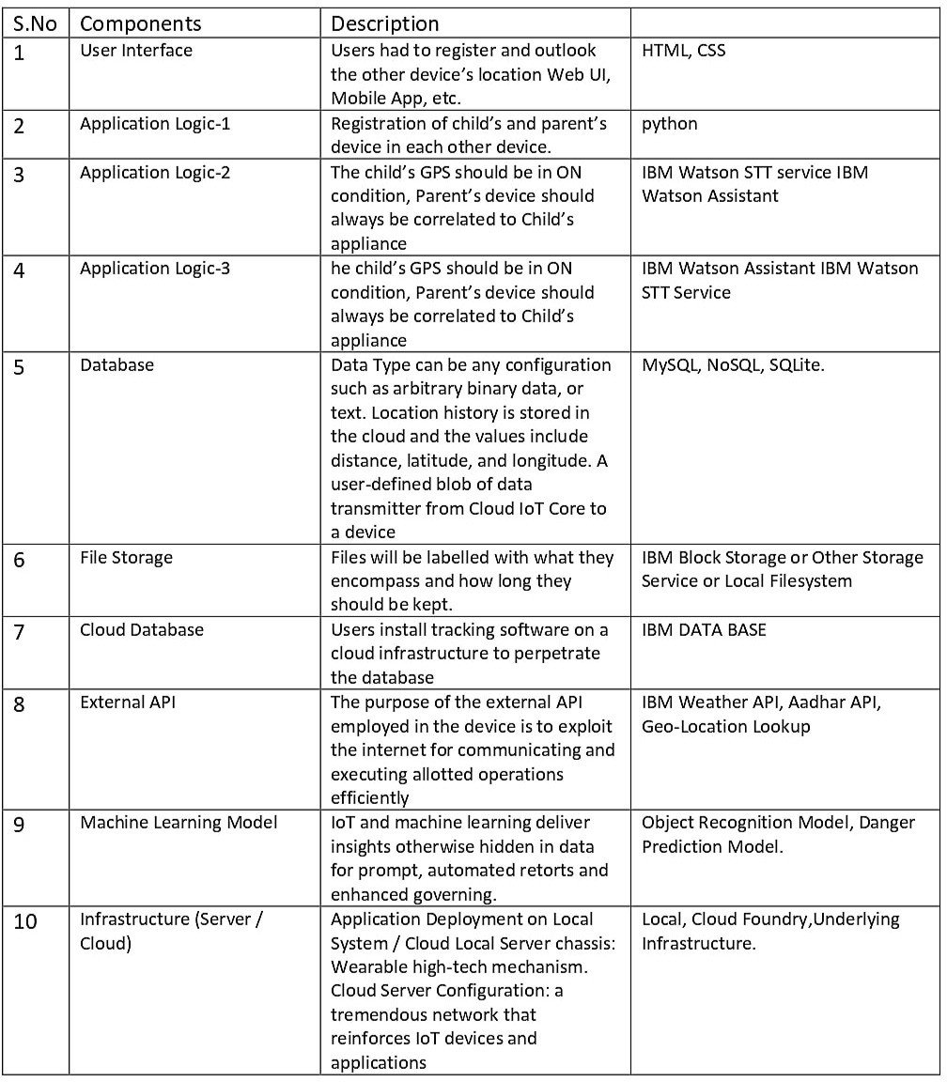

**Application Characteristics:**

|  |  |  |  |
| --- | --- | --- | --- |
| S.No | Characteristics | Description | Technology |
| 1. | Open source Frameworks | Tracking the location of children | Random data in python script. |
| 2. | Security Implementation | Device ID, IBM cloud and Watson account. | Eg.SHA-  256,Encryptions,IAM controls, OWSAP etc. |
| 3. | Scalable Architecture | Upgrade | IBM cloud |
| 4. | Availability | The app contains the Location data of the children. | GPS, Python script |
| 5. | Performance | The system continuously updates the location data and if the children cross the geofence it will show alert. | Mobile app, Web UI |

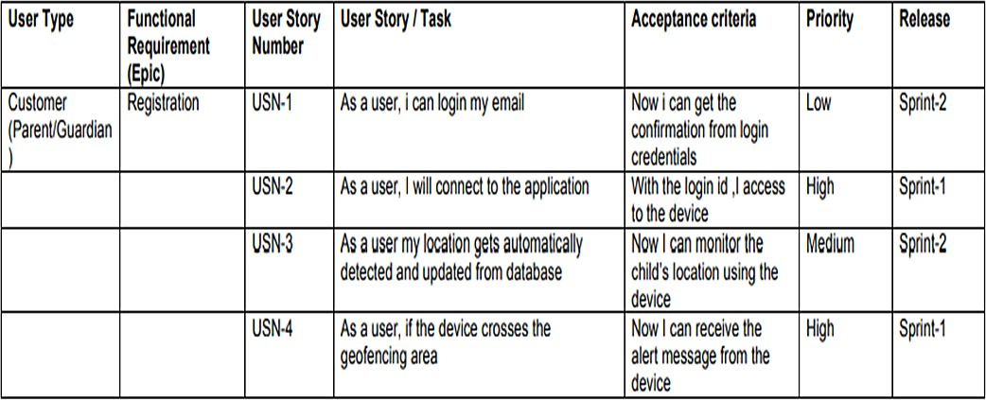

* 1. **User Stories:**

# PROJECT PLANNING AND SCHEDULING:

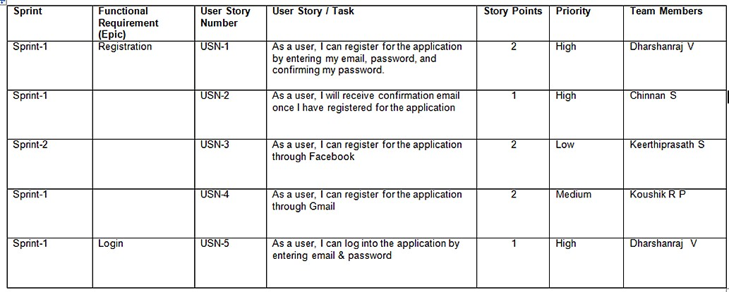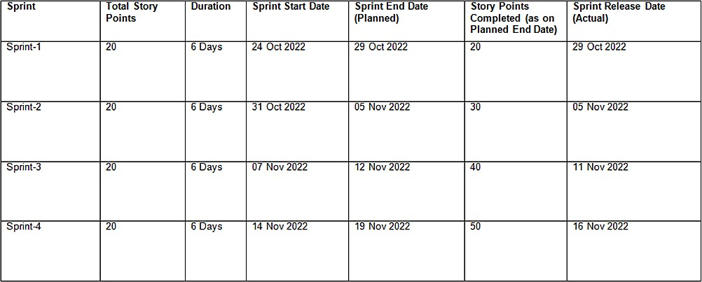

* 1. Sprint Planning and Estimation:

**Product Backlog, Sprint Schedule, and Estimation**

Use the below template to create product backlog and sprint schedule

#### Project Tracker, Velocity &Burn down Chart:

**Velocity:**

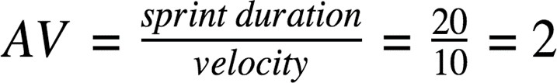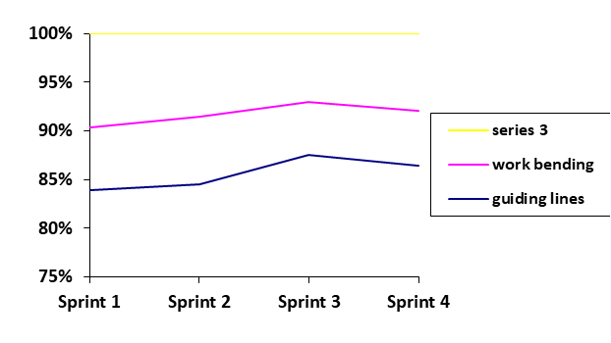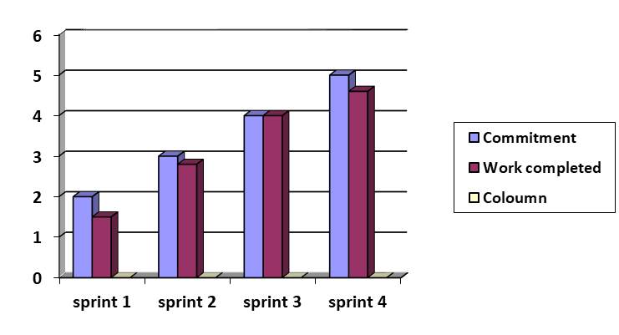

Imagine we have a 10-day sprint duration, and the velocity of the team is 20 (points per sprint). Let’s calculate the team’s average velocity (AV) per iteration unit (story points per day)

**BURNDOWN**

**6.3 Report From JIRA**

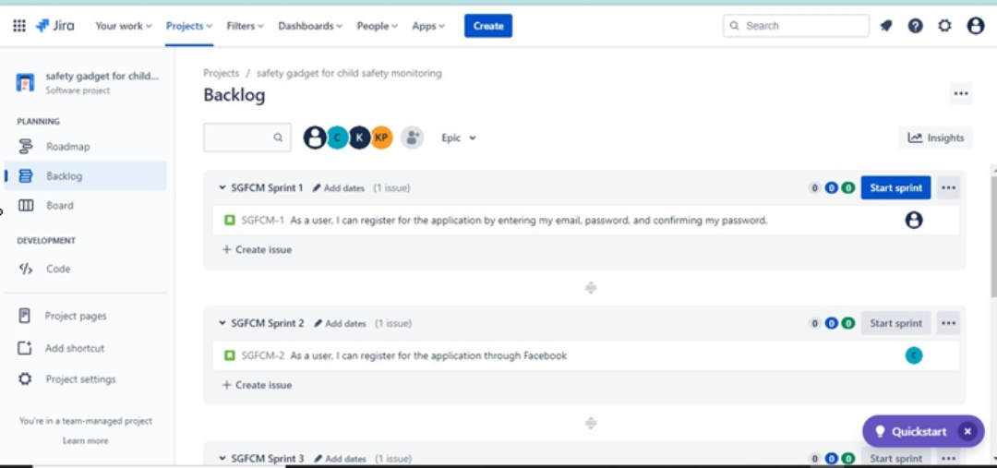

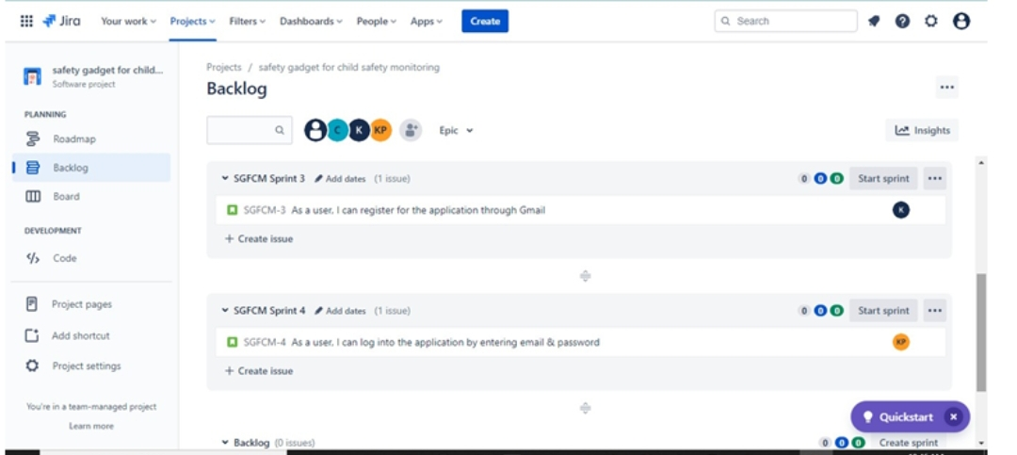

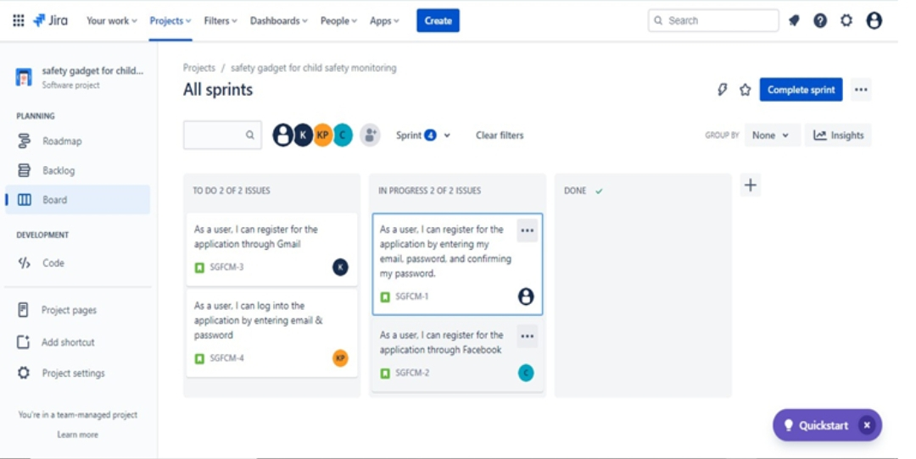

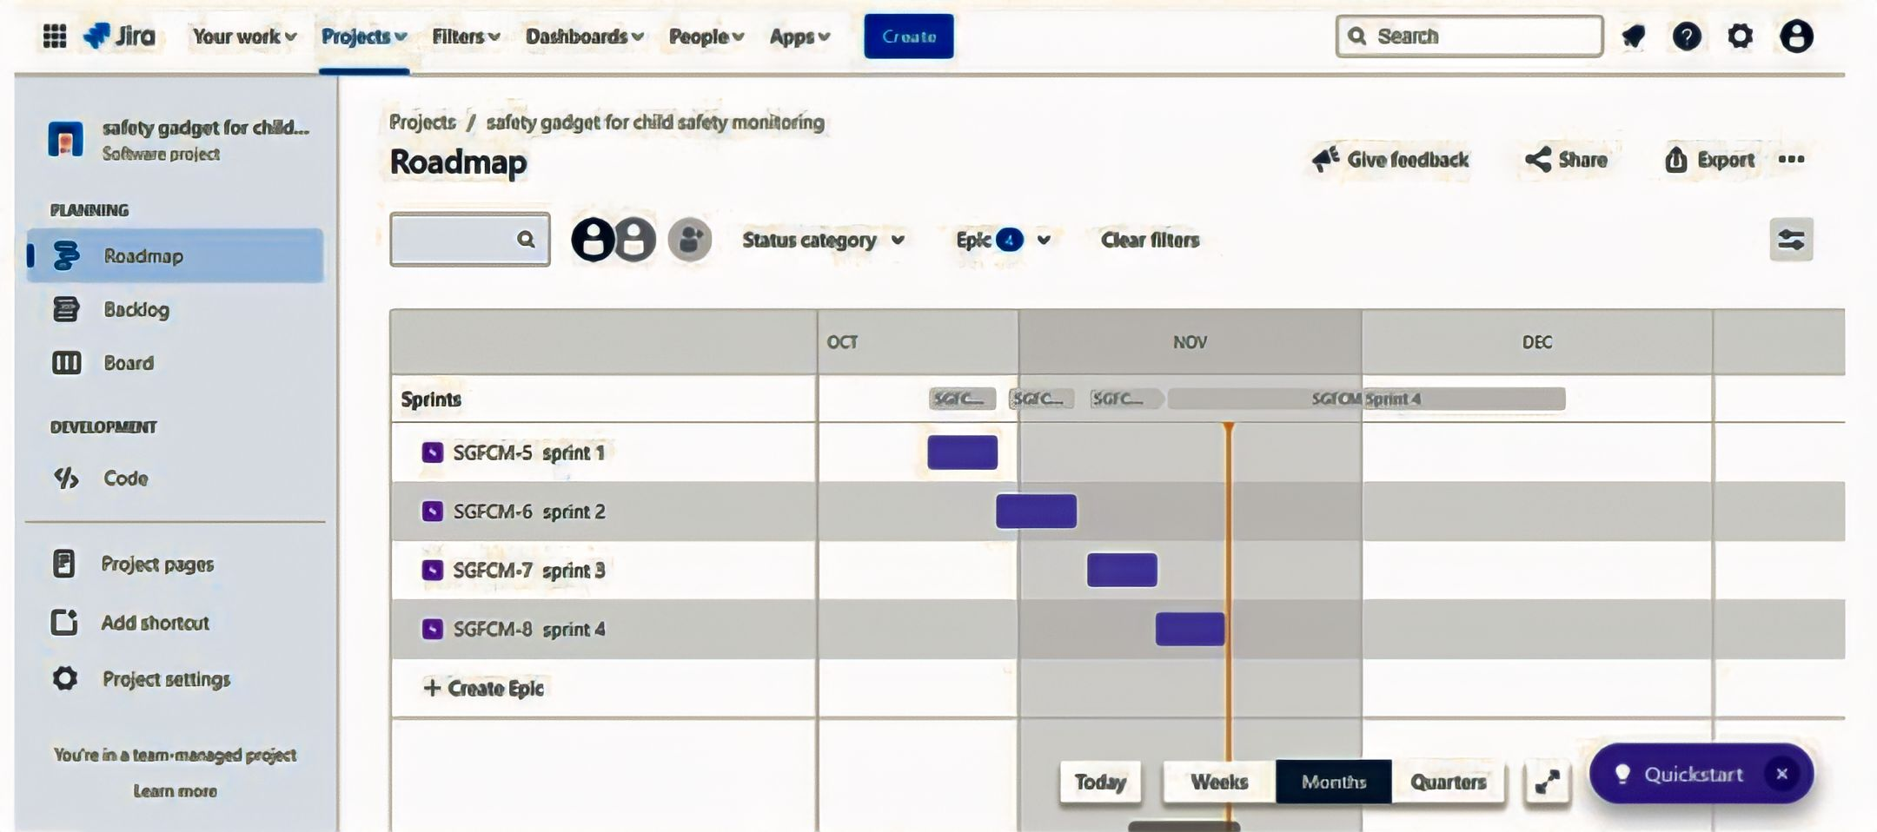

# CODING AND SOLUTIONING:

**(Explain the features added in the project along with web)**

## Feature Code:

import time import sys

importibmiotf.application importibmiotf.device import random

#Provide your IBM Watson Device Credentials organization = "933n2d"

deviceType = "koushik47" deviceId = "07" authMethod = "token" authToken = "87654321"

#apikey {a-illza1-mbdxqo6z0s}

#api token {zSYzISuAWF&F_x7GkT} try:

deviceOptions = {"org": organization, "type": deviceType, "id": deviceId, "auth-method": authMethod, "auth-token": authToken}

deviceCli = ibmiotf.device.Client(deviceOptions #..............................................

except Exception as e:

print("Caught exception connecting device: %s" % str(e)) sys.exit()

# Connect and send a datapoint "hello" with value "world" into the cloud as an event of type "greeting" 10 times

print("power on ")

print("checking connection to wastoniot...") time.sleep(2)

deviceCli.connect()

print("dear user ... welcome to IBM-IOT ")

print("i can provide your children live location and temperature ") print()

name=str(input("enter your child name:")) while True:

temperature=random.randint(20,85)#random temperature for your child latitude=random.uniform(12.1295314,12.1335137)#random latitude for your child longitude=random.uniform(78.1955059,78.1986357)#random longitude for your child

a="Child inside the geofence" b=" Child outside the geofence" c="High temperature"

d="Low temperature" x={'your_child_zone':a} y={'your_child_zone':b} z={'temp_condition':c} w={'temp_condition':d}

data = { 'temp' : temperature, 'lat': latitude,'lon':longitude,'name':name } #print data

defmyOnPublishCallback():

print ("Published Temperature = %s C" % temperature, "latitude = %s %%" % latitude, "longitude = %s

%%" % longitude, "to IBM Watson") print("\n")

success = deviceCli.publishEvent("IoTSensorgpsdata", "json", data, qos=0,on_publish=myOnPublishCallback)

if latitude>=12.1303598 and latitude<=12.1321095 and longitude >=78.1967589 and longitude

<=78.19820833:

deviceCli.publishEvent("IoTSensorgpsdata","json",data=x,qos=0,on_publish=myOnPublishCallback) print(x)

print("\n") else:

deviceCli.publishEvent("IoTSensorgpsdata","json",data=y,qos=0,on_publish=myOnPublishCallback) print(y)

print("\n")

if (temperature>=40): deviceCli.publishEvent("IoTSensorgpsdata","json",data=z,qos=0,on_publish=myOnPublishCallback) print(z)

print("\n") else:

deviceCli.publishEvent("IoTSensorgpsdata","json",data=w,qos=0,on_publish=myOnPublishCallback) print(w)

print("\n")

if not success:

print("Not connected to IoTF") print("\n")

time.sleep(1)

# Disconnect the device and application from the cloud deviceCli.disconnect()

# TESTING:

* 1. **Test case:**

|  |  |  |  |
| --- | --- | --- | --- |
| **SL.NO** | **INPUT** | **OUTPUT** | **RESULT** |
| **01.** | Latitude, Longitude  Temperature | Inside the geofence, Temperature low | Passed |
| **02.** | Latitude, Longitude  Temperature | Inside the geofence, Temperature high | Passed |
| **03.** | Latitude, Longitude  Temperature | Outside the geofence, Temperature low | Passed |
| **04.** | Latitude, Longitude  Temperature | Outside the geofence, Temperature low | Passed |
| **05.** | Latitude, Longitude  Temperature | Inside the geofence, Temperature low | Passed |
| **06.** | Latitude, Longitude  Temperature | Inside the geofence, Temperature high | Passed |
| **07.** | Latitude, Longitude  Temperature | Outside the geofence, | Passed |

|  |  |  |  |
| --- | --- | --- | --- |
|  |  | Temperature low |  |
| **08.** | Latitude, Longitude  Temperature | Inside the geofence, Temperature low | Passed |
| **09.** | Latitude, Longitude  Temperature | Inside the geofence, Temperature high | Passed |
| **10.** | Latitude, Longitude  Temperature | Inside the geofence, Temperature low | Passed |
| **11.** | Latitude, Longitude  Temperature | Inside the geofence, Temperature low | Passed |
| **12.** | Latitude, Longitude  Temperature | Outside the geofence, Temperature low | Passed |
| **13.** | Latitude, Longitude  Temperature | Inside the geofence, Temperature low | Passed |
| **14.** | Latitude, Longitude  Temperature | Inside the geofence, Temperature high | Passed |
| **15.** | Latitude, Longitude  Temperature | Outside the geofence, Temperature high | Passed |
| **16.** | Latitude, Longitude  Temperature | Outside the geofence,  Temperature low | Passed |
| **17.** | Latitude, Longitude  Temperature | Inside the geofence, Temperature low | Passed |

|  |  |  |  |
| --- | --- | --- | --- |
|  |  |  |  |
| **18.** | Latitude, Longitude  Temperature | Inside the geofence, Temperature high | Passed |
| **19.** | Latitude, Longitude  Temperature | Outside the geofence,  Temperature low | Passed |
| **20.** | Latitude, Longitude  Temperature | Outside the geofence,  Temperature high | Passed |
| **21.** | Latitude, Longitude  Temperature | Inside the geofence, Temperature low | Passed |
| **22.** | Latitude, Longitude  Temperature | Inside the geofence, Temperature high | Passed |
| **23.** | Latitude, Longitude  Temperature | Outside the geofence,  Temperature low | Passed |
| **24.** | Latitude, Longitude  Temperature | Inside the geofence, Temperature low | Passed |
| **25.** | Latitude, Longitude  Temperature | Outside the geofence, Temperature low | Passed |

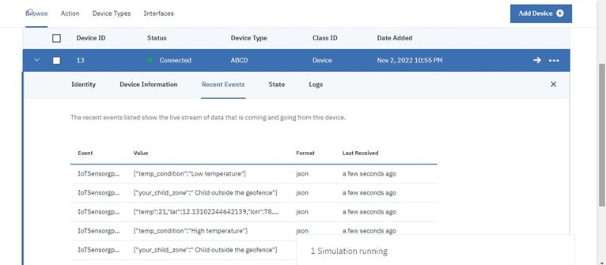

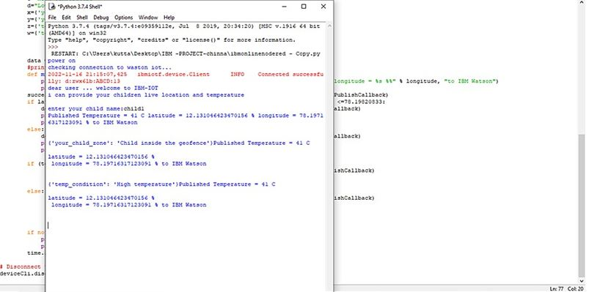

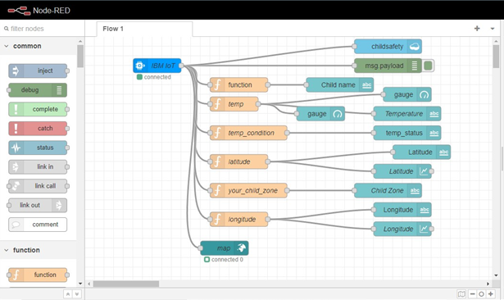

**User Acceptance Testing:**

## **Purpose of Document:**

The purpose of this document is to brieﬂy explain the test coverage and open issues of the IOT Based Safety Gadget For Child Safety Monitoring and Notiﬁcation project at the time of the release to User Acceptance Testing (UAT).

**Defect Analysis:**

This report shows the number of resolved or closed bugs at each severity level, and how they were resolved

|  |  |  |  |  |  |
| --- | --- | --- | --- | --- | --- |
| **Resolution** | **Severity 1** | **Severity 2** | **Severity 3** | **Severity 4** | **Subtotal** |
| By Design | 5 | 3 | 2 | 3 | 13 |
| Duplicate | 1 | 0 | 0 | 0 | 1 |
| External | 2 | 2 | 0 | 1 | 5 |
| Fixed | 6 | 5 | 3 | 10 | 24 |
| Not Reproduced | 0 | 0 | 1 | 0 | 1 |
| Skipped | 0 | 0 | 1 | 1 | 2 |
| Won't Fix | 0 | 0 | 2 | 1 | 3 |
| Totals | 14 | 10 | 9 | 16 | 4  9 |

## **Test Case Analysis**

This report shows the number of test cases that have passed, failed, and untested

|  |  |  |  |  |
| --- | --- | --- | --- | --- |
| **Section** | **Total Cases** | **Not Tested** | **Fail** | **Pass** |
| Print Engine | 7 | 0 | 0 | 7 |
| Client Application | 30 | 0 | 0 | 30 |
| Security | 2 | 0 | 0 | 2 |
| Outsource Shipping | 3 | 0 | 0 | 3 |
| Exception Reporting | 9 | 0 | 0 | 9 |
| Final Report Output | 4 | 0 | 0 | 4 |
| Version Control | 2 | 0 | 0 | 2 |

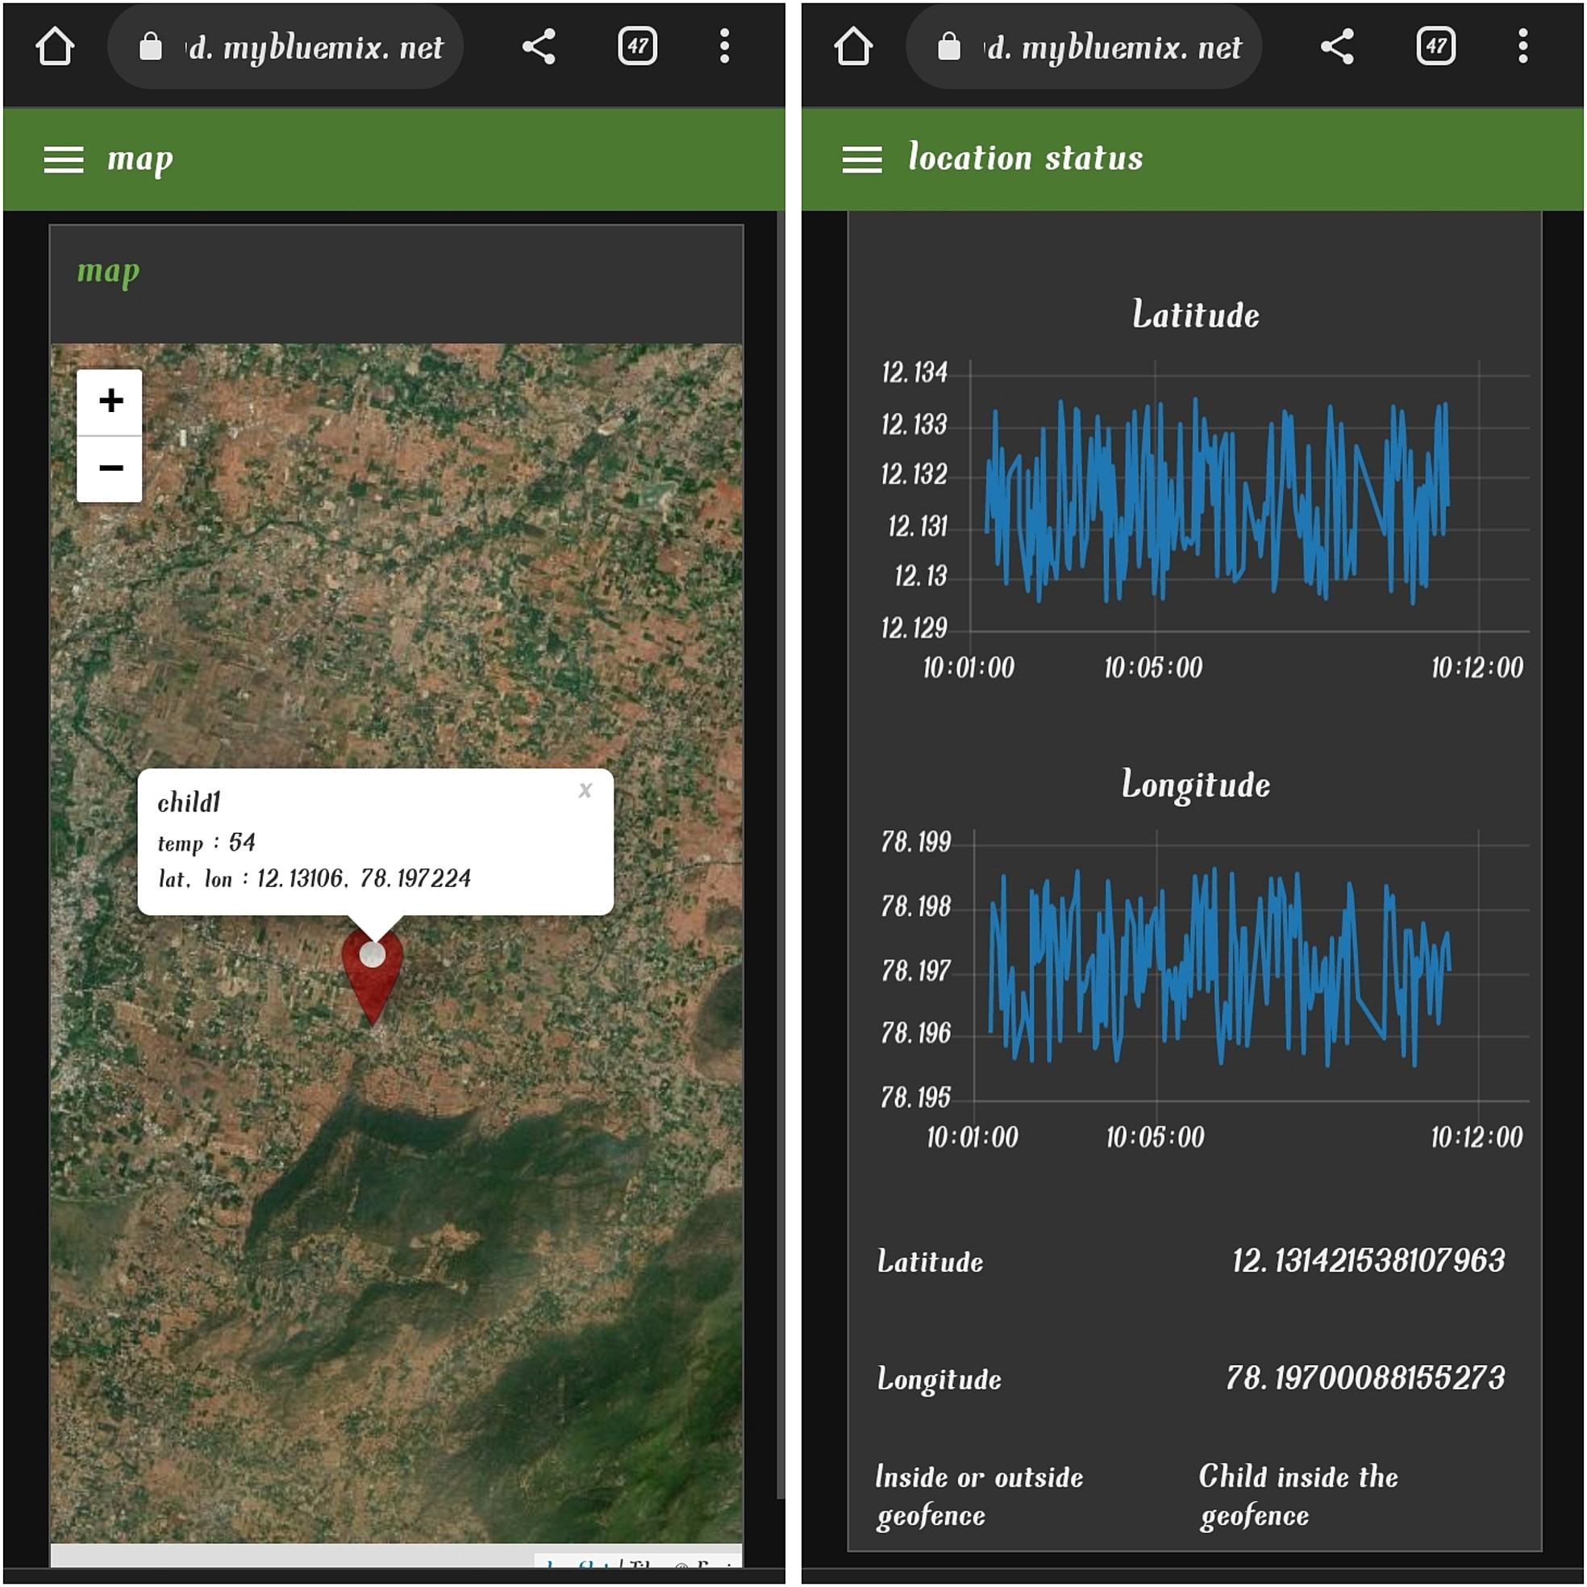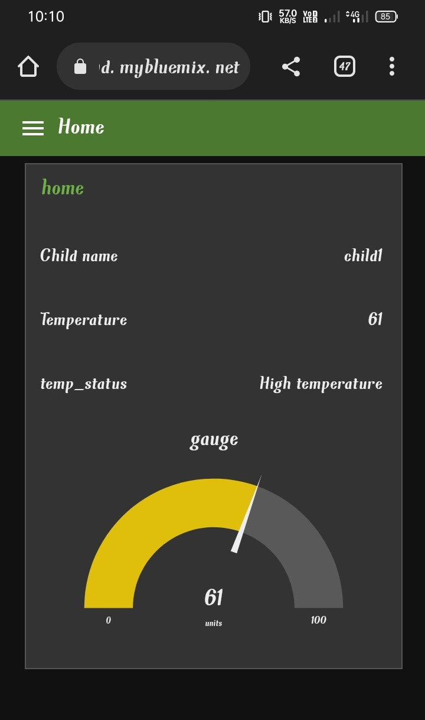

# RESULTS:

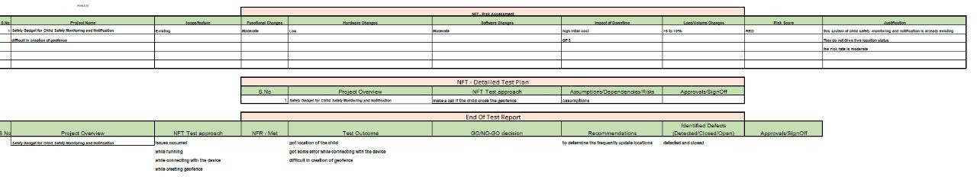

* 1. Performance metrics

# ADVANTAGES AND DISADVANTAGES

## **Advantages:**

1. Save the life of the children.
2. Parent’s do their work peacefully without worrying about their children.
3. Continously monitoring the children.
4. Saves time.
5. Recovery of the children is easy, if the children lost.

## **Disadvantages:**

1. Young Children may refuse to cooperate unless allowed to play with their gadgets.
2. Easily misusing the device.
3. No water proof.

# CONCLUSION:

The child tracking system that helps parents track the movements of children with the help of GPS technology. The entire location data is stored in database. This proposed app can shows the whether the children inside the geofence or outside the geofence to the parent’s mobile . Even if the software is not running, the details are shown. It is because location access is available in the background and the software performs well on the mobile device. Based on the availability of the parent user, additional geofences may be required. Performance Requirements are summarized as follows: login, Location status, temperature ,Live on map etc. The system shall allow the user to create and/or log in to an account. The system shall allow the user to ﬁnd the exact location of the children using GPS. The system shall allow the user to track the current location of the children using GPS.

# FUTURE SCOPE:

1. Childs surrounding can be located with the help of accurate and precise real time location.
2. Surrounding environment temperature, SOS light along with Distress buzzers are provided in this system.
3. If child crosses the geofence, call goes to the registered mobile number’s.
4. This gadgets will be modiﬁed that has been suitable for all environments.

# APPENDIX:

## Python code:

import time import sys

importibmiotf.application importibmiotf.device import random

#Provide your IBM Watson Device Credentials organization = "933n2d"

deviceType = "koushik47" deviceId = "07" authMethod = "token" authToken = "87654321"

#apikey {a-illza1-mbdxqo6z0s}

#api token {zSYzISuAWF&F_x7GkT} try:

deviceOptions = {"org": organization, "type": deviceType, "id": deviceId, "auth-method": authMethod, "auth-token": authToken}

deviceCli = ibmiotf.device.Client(deviceOptions) #..............................................

except Exception as e:

print("Caught exception connecting device: %s" % str(e)) sys.exit()

# Connect and send a datapoint "hello" with value "world" into the cloud as an event of type "greeting" 10 times

print("power on ")

print("checking connection to wastoniot...") time.sleep(2)

deviceCli.connect()

print("dear user ... welcome to IBM-IOT ")

print("i can provide your children live location and temperature ") print()

name=str(input("enter your child name:")) while True:

temperature=random.randint(20,85)#random temperature for your child latitude=random.uniform(12.1295314,12.1335137)#random latitude for your child longitude=random.uniform(78.1955059,78.1986357)#random longitude for your child

a="Child inside the geofence" b=" Child outside the geofence" c="High temperature"

d="Low temperature"

x={'your_child_zone':a} y={'your_child_zone':b} z={'temp_condition':c} w={'temp_condition':d}

data = { 'temp' : temperature, 'lat': latitude,'lon':longitude,'name':name } #print data

defmyOnPublishCallback():

print ("Published Temperature = %s C" % temperature, "latitude = %s %%" % latitude, "longitude = %s

%%" % longitude, "to IBM Watson") print("\n")

success = deviceCli.publishEvent("IoTSensorgpsdata", "json", data, qos=0, on_publish=myOnPublishCallback)

if latitude>=12.1303598 and latitude<=12.1321095 and longitude >=78.1967589 and longitude

<=78.19820833:

deviceCli.publishEvent("IoTSensorgpsdata","json",data=x,qos=0,on_publish=myOnPublishCallback) print(x)

print("\n") else:

deviceCli.publishEvent("IoTSensorgpsdata","json",data=y,qos=0,on_publish=myOnPublishCallback) print(y)

print("\n")

if (temperature>=40):

deviceCli.publishEvent("IoTSensorgpsdata","json",data=z,qos=0,on_publish= myOnPublishCallback)

print(z) print("\n") else:

deviceCli.publishEvent("IoTSensorgpsdata","json",data=w,qos=0,on_publish=myOnPublishCallback) print(w)

print("\n")

if not success:

print("Not connected to IoTF") print("\n")

time.sleep(1)

# Disconnect the device and application from the cloud deviceCli.disconnect()

## **GitHub & Project demo link:**

GitHub Link:  <https://github.com/IBM-EPBL/IBM-Project-14261-1659547652>

MIT App APK File Link:

<https://drive.google.com/file/d/1wl6CvdzqxU1_ljjNMtDOxadzL1ERuLX/view?usp=sharing>

Project Demonstration Video Link:

<https://drive.google.com/file/d/1SK2nOhzfaPgK4-jvZe4QCmmlAWn5jOH_/view?usp=sharing>